**Install IQ Service:**

**Step-1 :** uninstall old IQ service

🡪run cmd from “C:\SailPoint\IQService” and run below command

* **IQService.exe -u**

**Step-2:** Delete IQService folder in “C:\SailPoint”

**Step-3:** copy IQService Zip file from the IIQ installation directory

“<IIQ directory>\WEB-INF\bin\win\IQService.zip”

**Step-4:** Extract the Zip and past it “C:\SailPoint”

**Step-5:** install old IQ service

🡪run cmd from “C:\SailPoint\IQService” and run below command

* **IQService.exe -i**

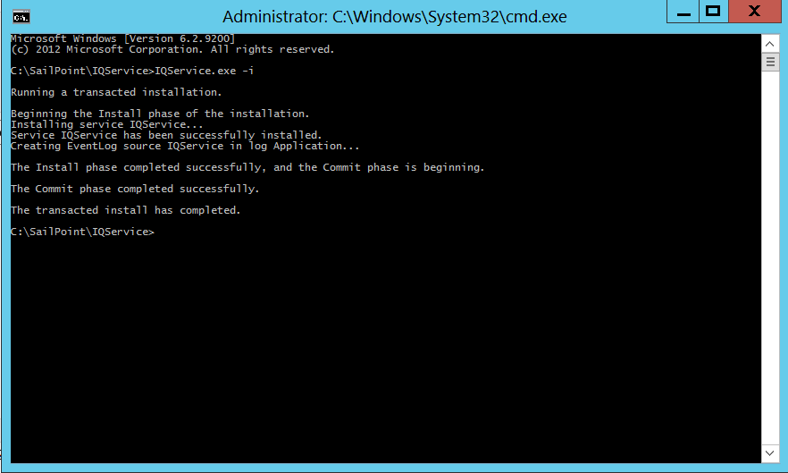

OR

Upgrading IQService

Perform the following:

1. Take backup of existing IQService installation.
2. Ensure that IQService is stopped through Applet Services or by using the following command:  
   IQService.exe -k
3. Uninstall IQService using the following command:  
   IQService -u
4. Extract latest IQService in the existing installation directory.
5. Install IQService using the following command:  
   IQService -i
6. Start IQService from services or by using the following command:  
   IQService.exe -s

<https://community.sailpoint.com/t5/Other-Documents/IQService/ta-p/158011#toc-hId-1620807964>

**Troubleshooting issues:**

https://community.sailpoint.com/t5/Product-Guides/IQService-Troubleshooting/ta-p/76780